Raspberry Pi Setup Documentation

Step 1: Make sure you have all the hardware required

Hardware (existing):

Microscope

Hardware to make (3D print):

Hardware (to buy):

1. Raspberry Pi 4 Model B
2. Raspberry Pi case (with open section)
3. Raspberry Pi charger
4. Raspberry Pi camera
5. Raspberry Pi fan
6. Raspberry Pi heatsink
7. Raspberry Pi HDMI adapter
8. MicroSD card (at least 8GB)

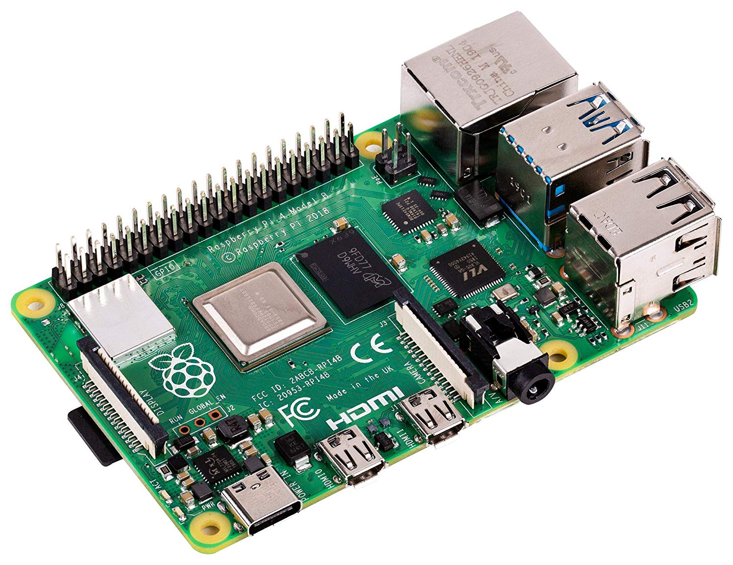

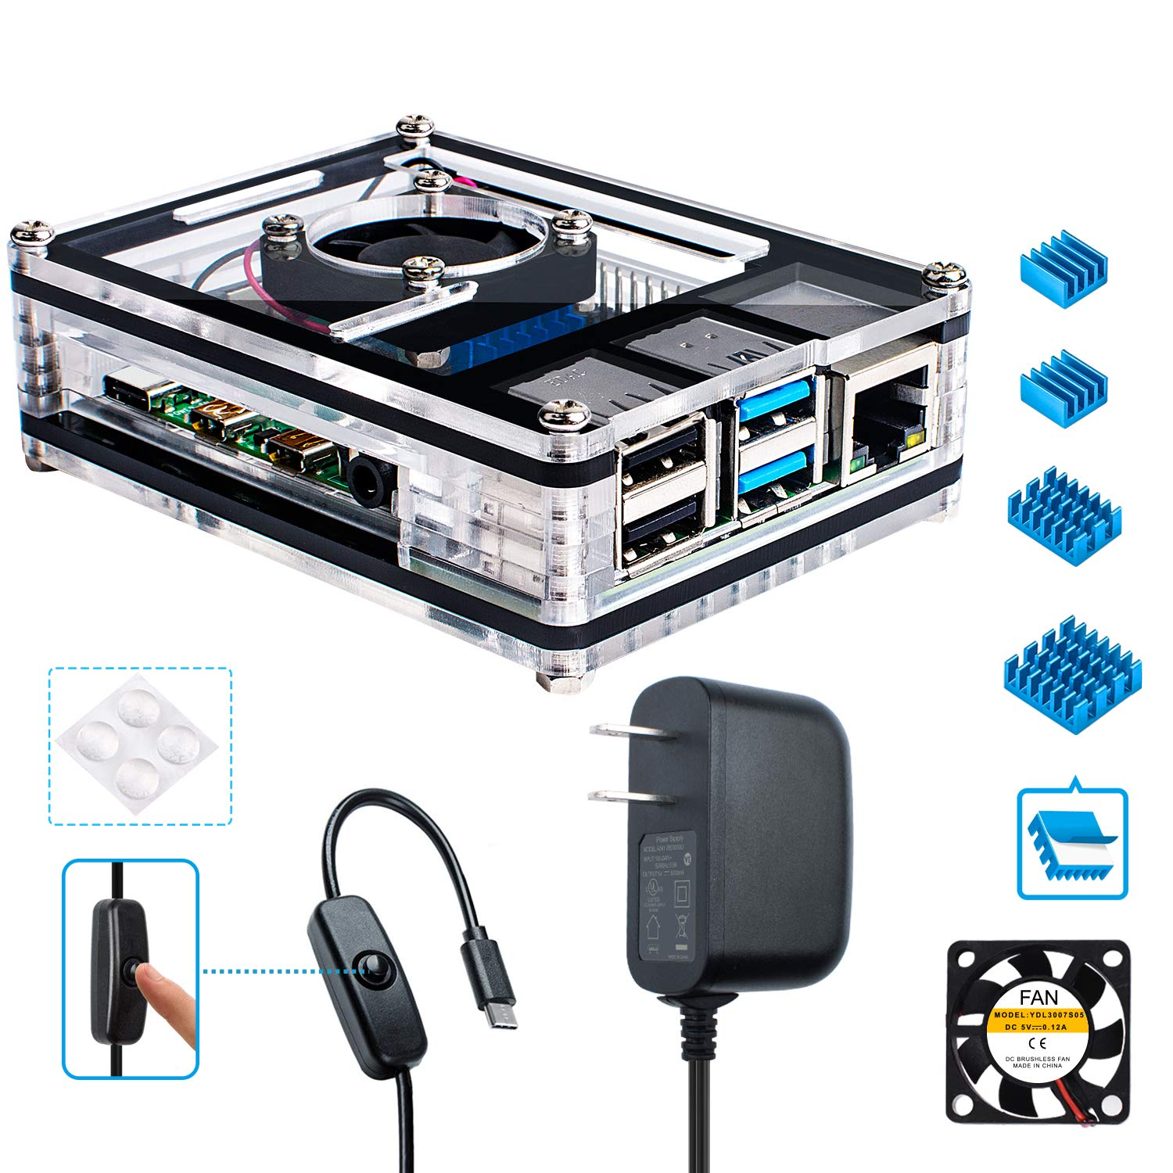

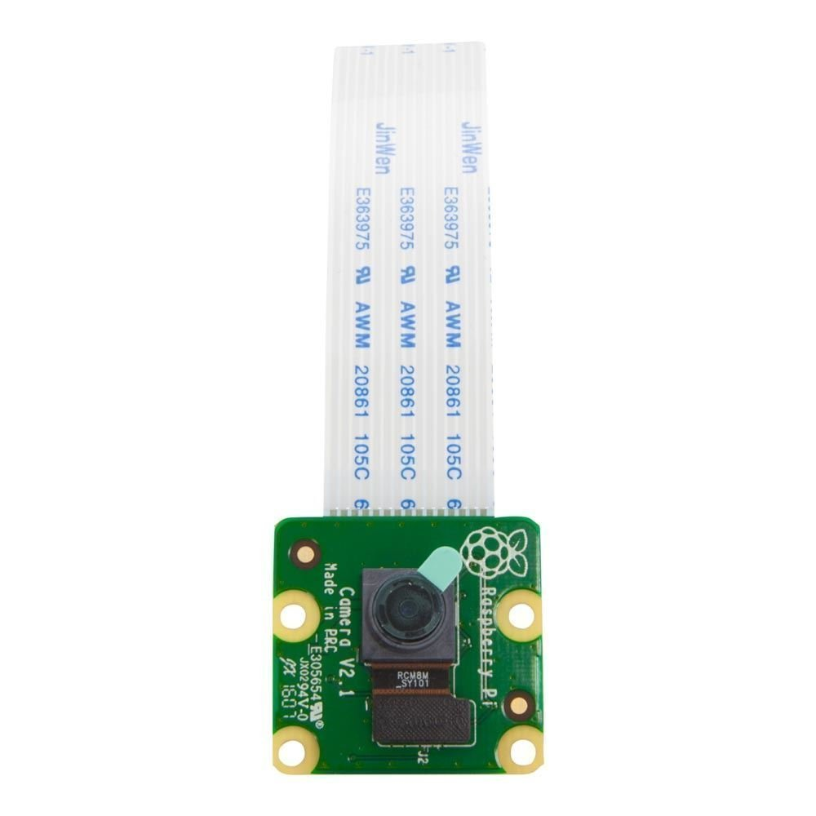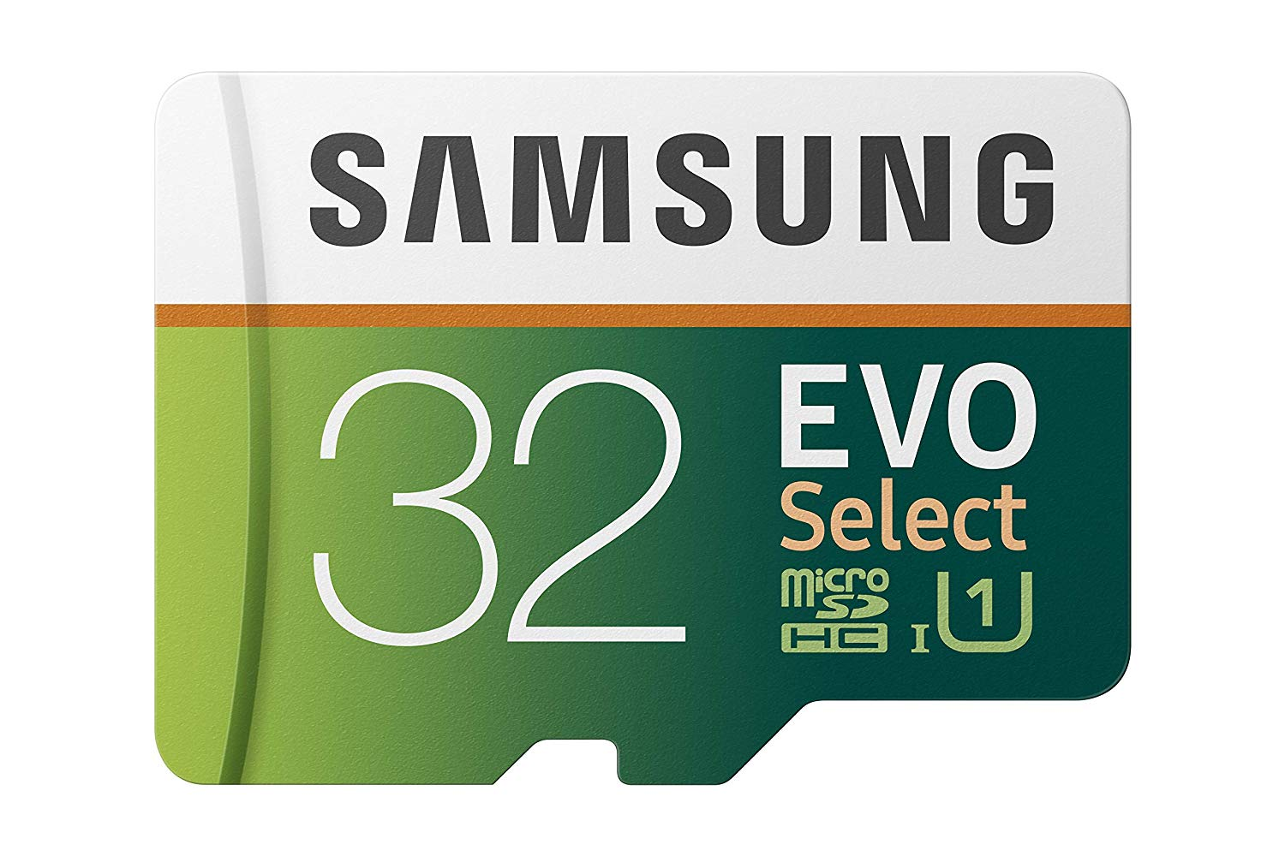

Step 2: Setting up the microSD card

This step will install the operating system Noobs into the microSD card so it can be used in the Raspberry Pi.

1. Open microSD card and insert into computer.
2. Go to <https://www.raspberrypi.org/downloads/noobs/> and download Noobs zip file.
3. Go to <https://www.raspberrypi.org/help/noobs-setup/2/> and follow the directions.
   1. When download is finished extract the files from the zip.
   2. Go to <https://www.sdcard.org/downloads/formatter/> and download the SD Formatter 4.0 for either Windows/Mac.
   3. Install SD Formatter 4.0 and then run it.
   4. In SD Formatter 4.0, format microSD card.
   5. Move the extracted Noobs files into the now formatted microSD card.
   6. Remove microSD card safely.
4. Remove microSD card safely.

Step 3: Setting up Raspberry Pi and its corresponding hardware

1. Insert microSD card into Rasberry Pi slot and set aside.
2. Follow the instructions of the Raspberry Pi case (included with the case).
   1. Before closing the top/lid attach the Raspberry Pi, feed the camera strip through the slot and connect it to the Pi. When connecting the camera, lift the black strip of insert on the pi device, insert strip, then secure black strip.
3. Remove film on camera.